Boolean

* Primitive value
* Represent the answer to true/false questions
* 2 values:
  + true
  + false



Sample primitives

* >, >=, <, …

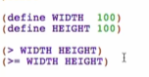

Predicates

* Primitives or functions that produce a Boolean value
  + Primitives
    - Comparison operators
    - See Discovering Primitives for Dr Racket for more
  + Functions
    - Defined functions that return a Boolean value

Predicates on string

* (string=? “string1” “string2”)
* Check if strings are the same

Predicates on images

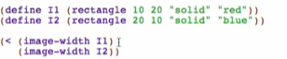 -> 

* With the help of image functions in this case: (image-width [image]) which returns a number